Keeping Grain in Good Condition Through the Winter

Klein E. Ileleji, Extension Engineer, Purdue University

Purdue Extension Pest & Crop Newsletter, October 12, 2017
Harvest is already in full swing, but has slowed down due to the constant rainfall in the last few days. It appears that the corn and soybean crop had a pretty good field dry-down on average, and USDA crop progress report for the Midwest rated 64% of the corn crop as good to excellent. What is important now is ensuring that the crop is dried to safe moisture and cooled down appropriately so that it remains in good condition until prices are favorable enough to sell.
Table 1. Maximum moisture contents for grain harvest and safe storage recommended in the Midwest. (Source: Grain Drying, Handling and Storage handbook, third edition, MWPS-13). Values for good quality, clean grain and aerated storage. Reduce safe storage moisture content by 1% for poor quality grain.
Grain Type | Max Moisture Content, %wb  At Harvest | Max Moisture Content, %wb  Storage Period  Up to 6 Months* | Max Moisture Content, %wb  Storage Period  6-12 Months** | Max Moisture Content, %wb  Storage Period  >1 Year**
Shelled corn and grain sorghum | 30 | 15 | 13 | 13
Soybeans | 18 | 13 | 12 | 11
Wheat, barley and oats | 20 | 14 | 13 | 12
Flaxseed | 15 | 9 | 7 | 7
Canola | 14 | 9 | 8 | 8
Sunflower | 17 | 10 | 8 | 8
Edible beans | 16 | 16 | 13 | 13
*Up to 6 months from harvest refers to storage under winter conditions.
**6-12 months and >1 year storage refers to storage into the warm summer months.
First of all, make sure your bins have been cleaned out thoroughly off old grain and foreign material. Applying an empty bin treatment on the bin wall and floor to control for insect pests is a good precautionary measure to implement. A list of grain protectants approved for stored grain in Indiana can be found on Purdue Extension bulletin entitled “Stored Product Pests”, E-66-W (accessed at: https//extension.entm.purdue.edu/publications/E-66.pdf). Second, the initial grain quality and moisture content dictates how long grain should be held in storage. Harvesting timely and drying adequately to safe moisture content are two key decisions that could affect how well you will be able to manage your grain in storage. Unfortunately, the late replanting of some fields mean some of the harvest will be done late into the fall. In rainy weather, check to see whether binned dry grain is not getting rewetted from rain drifts coming in through vents or open manholes. Provide adequate ventilation to the headspace above the grain to control condensation and prevent high humidity environment favorable to mold growth using roof exhaust fans. Check bins for rain drifts or water leakage, especially after a heavy rain event.

Table 1 shows recommended maximum moisture content values for grain harvest and safe storage for some grains grown in the Midwest. It is important to note that storing beyond the following spring means that the grain will be held over the warm summer months. Therefore, factor in the exposure of grain to warm storage conditions in the warm summer months, which reduce grain storability. Dry grain down to moisture levels based on your long-term storage plan.
Table 2. Aeration phases for stored grain in the fall (Source: Dr. Dirk Maier, Iowa State University, Ames, IA)
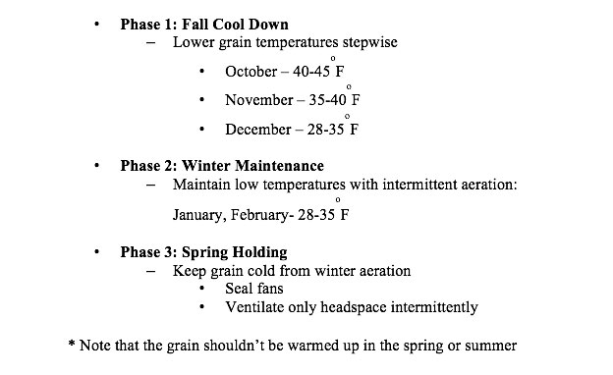
The last point I would like to make is cool stored grain adequately upon drying and after binning. Cooling grains to low winter temperatures as fast as possible will retard all biological activities that are detrimental to stored grain quality. Cooling stored grain to at least 40 degrees by December (weather permitting) should be your goal. Ensure fans are ready for use and have been sized to deliver sufficient airflow, at least 0.1 CFM per bushel for bins in the Midwest with grain depths up to 21 feet, and 0.03 to 0.05 CFM per bu for large bins over 50ft depth. Follow the stepwise three-phase aeration strategy shown on Table 2 to cool grain to next spring.
Finally, be safe when working around grain bins. Remember, a grain bin is a confined space and pose a hazard to personnel working inside it. Follow recommended guidelines for safely working in grain bins; never work alone. Make sure you discuss the dangers and precautionary measures taken while working around grain bins to your family and all your staff.
Source: https://extension.entm.purdue.edu/pestcrop/2017/Issue27/#5

